CYBERSECURITY INTERNSHIP
Organization name: Elevate labs

Student Name: Radhika Lakshmi. Teeramdasu
University: Aditya University
Domain: Cybersecurity
Duration: 1st January 2026 to 30th April 2026

TASK-3: Networking Basics for Cyber Security

In cyber security, understanding networking is essential because all digital communication happens through networks. Whether it is browsing a website, sending an email, or accessing cloud services, data is constantly exchanged in the form of packets. By learning how these packets move and behave, a security professional can identify abnormal activities, investigate attacks, and strengthen network defences. In this task, Wireshark is used to capture and analyze live network traffic to gain practical exposure to core networking protocols.

- IP Address:
An IP address acts as a unique identifier assigned to each device connected to a network. It ensures that data packets are delivered to the correct system, similar to how a postal address ensures letters reach the correct home.
- MAC Address:
A MAC address is a permanent hardware address assigned to a network interface. It is used within local networks to identify devices and remains constant regardless of network changes.

- DNS (Domain Name System):
DNS is responsible for converting easy-to-remember website names into machine-readable IP addresses. Without DNS, users would need to manually enter IP addresses to access websites.
- TCP (Transmission Control Protocol):
TCP is designed to provide reliable communication. It establishes a connection before data transfer and ensures that packets arrive in the correct order without loss.
- UDP (User Datagram Protocol):
UDP focuses on speed rather than reliability. It sends data without establishing a connection, making it suitable for applications where fast transmission is more important than accuracy.

- WIRESHARK:

Wireshark is a powerful, open-source network protocol analyzer that is widely used by network administrators, cybersecurity professionals, and students to capture, monitor, and analyze network traffic in real time. It allows users to see exactly what data is being transmitted over a network, helping them understand network behavior, detect problems, and identify security threats. Because of its accuracy, transparency, and extensive protocol support, Wireshark is considered one of the most essential tools in networking and cybersecurity.

Wireshark works by capturing data packets that travel across a network interface such as Ethernet, Wi-Fi, or virtual adapters. These packets contain detailed information including source and destination IP addresses, protocol types, port numbers, packet size, timestamps, and payload data. Wireshark then decodes these packets and presents them in a human-readable format, making it easier to analyze complex network communications. It supports thousands of protocols, ranging from basic ones like TCP, UDP, and HTTP to advanced protocols used in VoIP, IoT, and cloud environments.

Install Wireshark:
Steps: -
- Open a Web Browser
- Visit the Official Wireshark Website
Go to the official website:
https://www.wireshark.org
(Always use the official site to avoid malware or fake installers.)
- Download Wireshark for Windows
- Click on Download.
- Under the Windows Installer (64-bit) section, click the download link.
- The installer file (usually .exe) will start downloading.
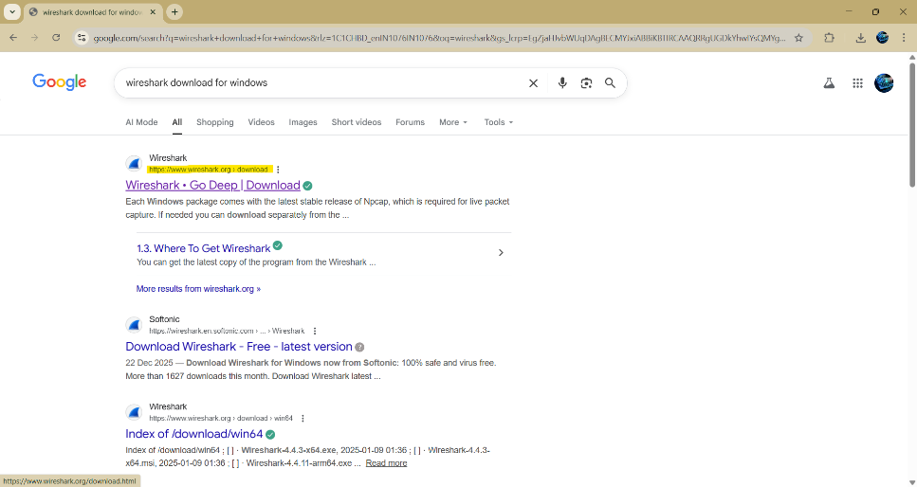
- Run the Installer

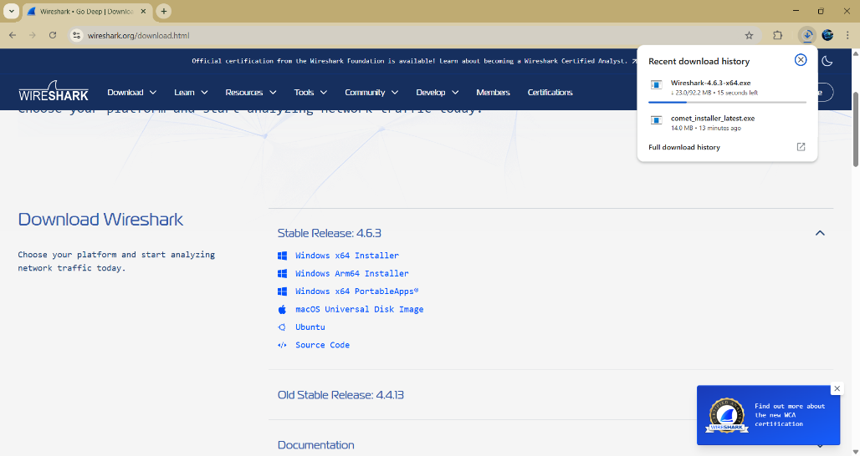

Capturing live traffic using wireshark:
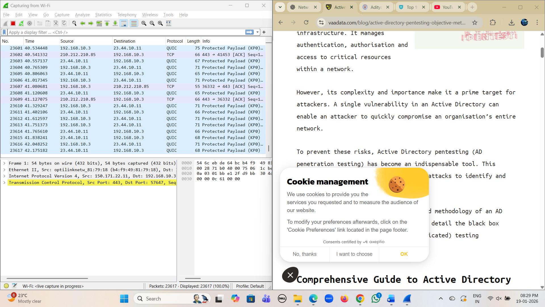
By opening any website will capture the live network traffic by the wireshark.
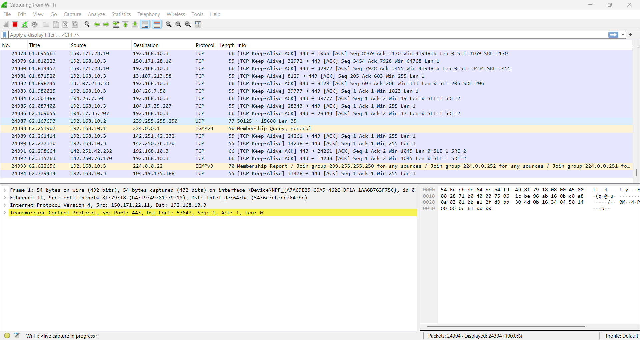

While capturing the live traffic, various TCP, UDP, DNS protocols are captured.

- Filter packets by protocol (HTTP, DNS, TCP):

- DNS:
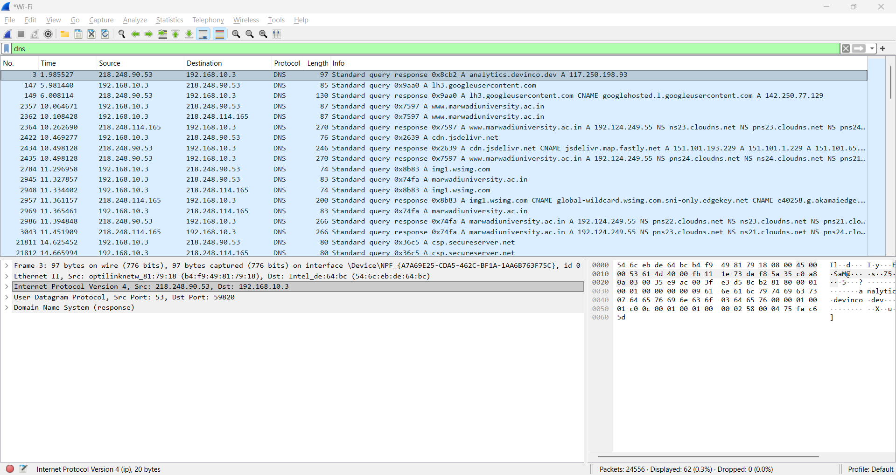
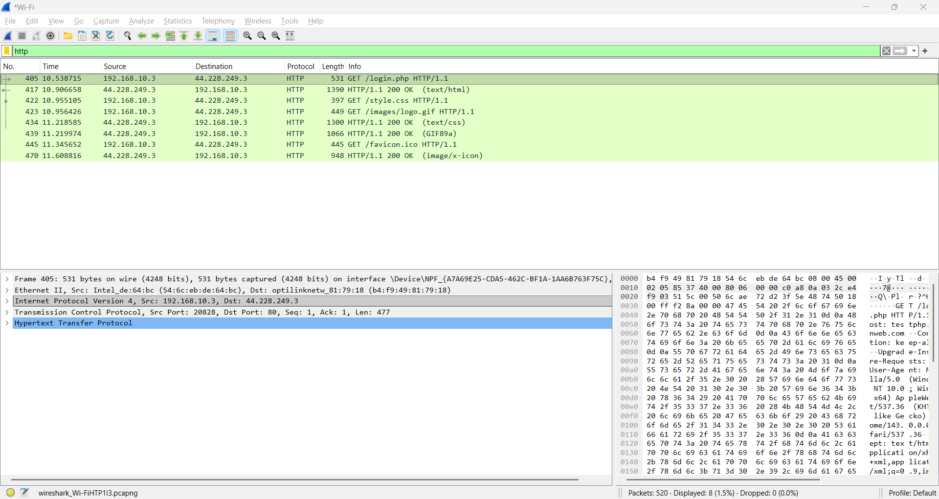
- HTTP:

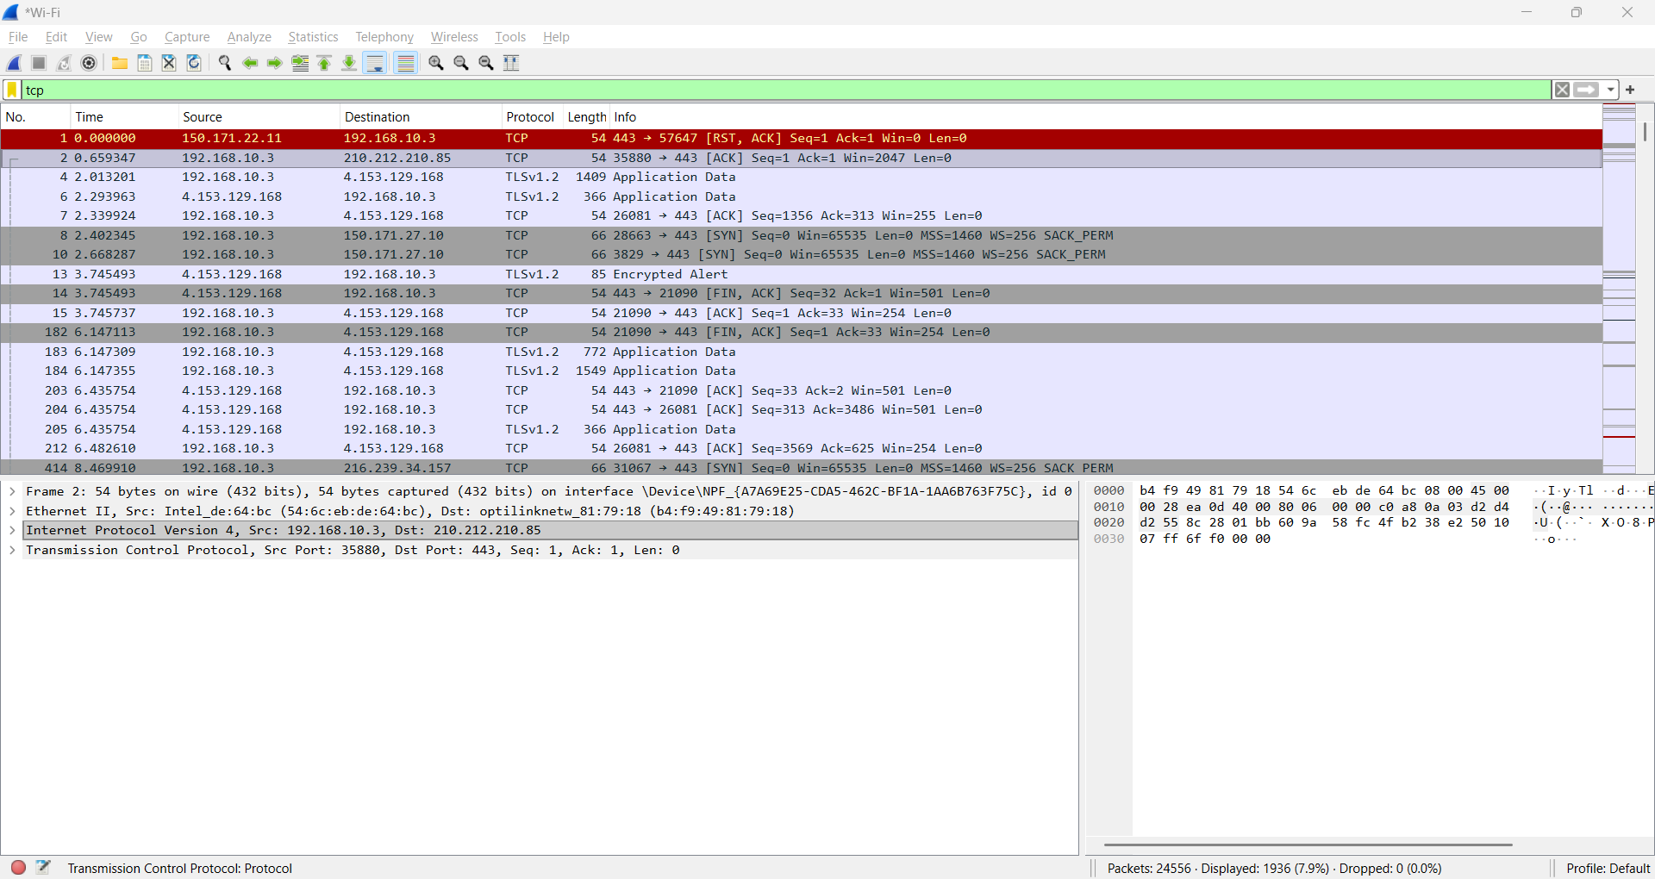
- TCP:

- Observe three-way TCP handshake:

The three-way TCP handshake is the process used to establish a reliable connection between a client and a server before any actual data transfer takes place. In this process, the client first sends a SYN (synchronize) packet to the server, indicating its request to start a connection. The server then responds with a SYN-ACK (synchronize acknowledgment) packet, confirming that it has received the request and is willing to communicate. Finally, the client sends an ACK (acknowledgment) packet back to the server, completing the connection setup. Once these three steps are successfully completed, a stable and reliable TCP connection is established, allowing data to be transmitted securely and in the correct order between both systems.

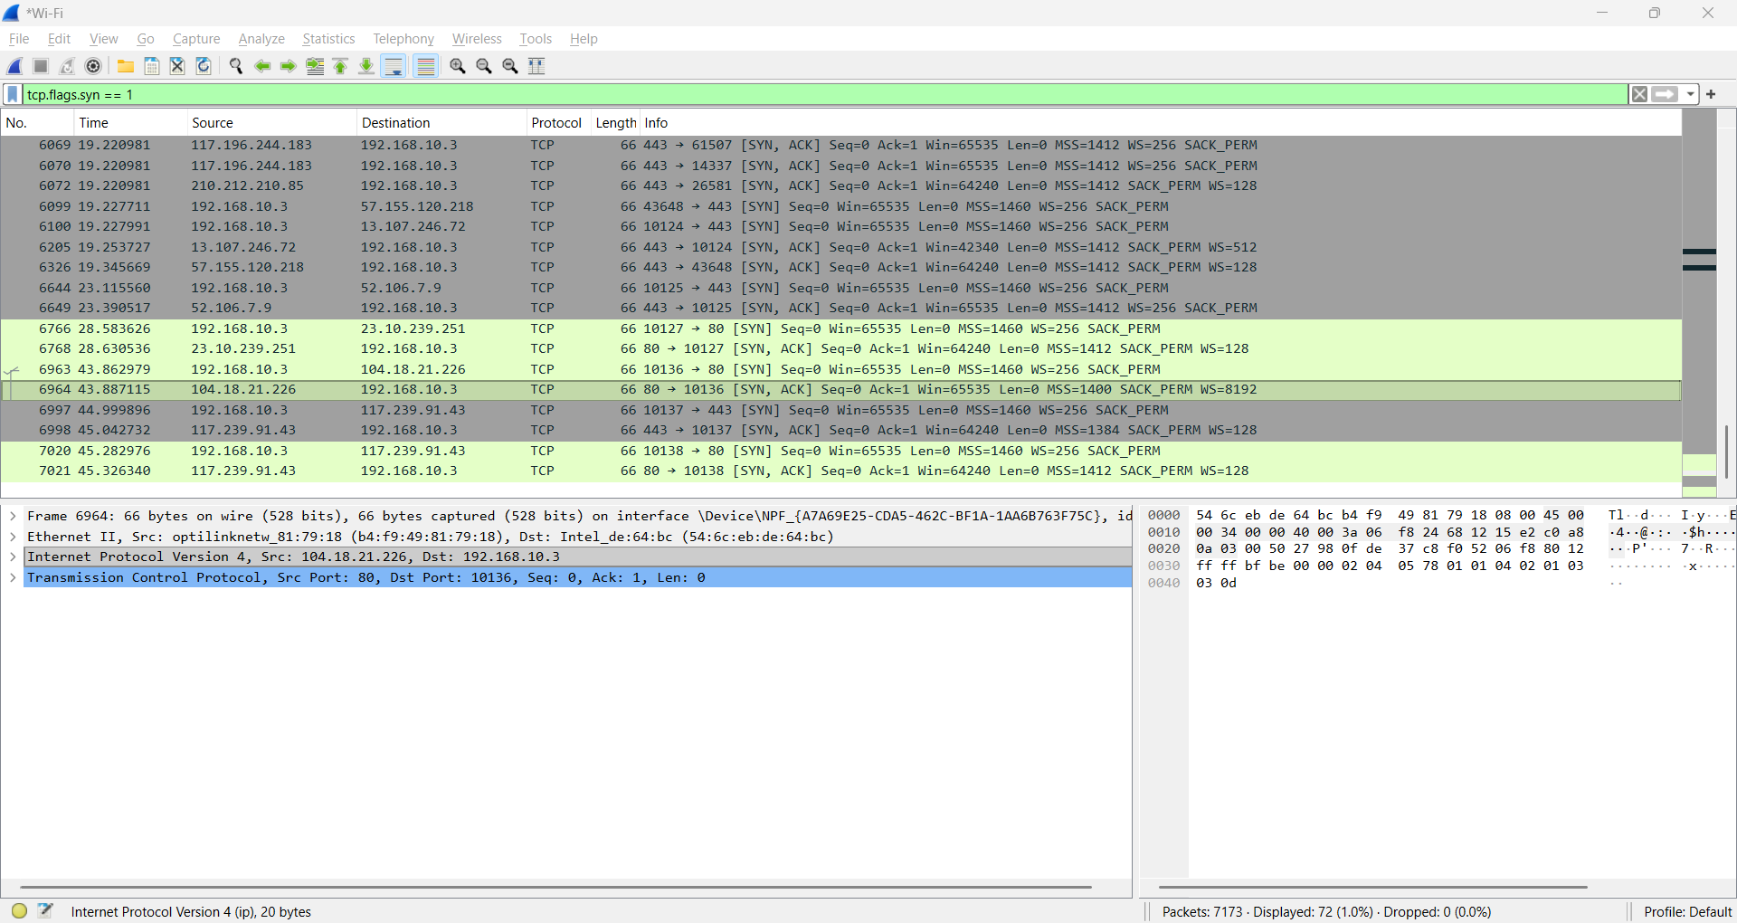
Here, the successful 3-way hand shake process is seen.

- Identify plain-text traffic vs encrypted traffic:
When browsing HTTP websites, some request details are visible in plain text. In contrast, HTTPS traffic appears scrambled due to encryption, highlighting the importance of secure communication.
HTTP traffic – with some clear information at the footer edge.
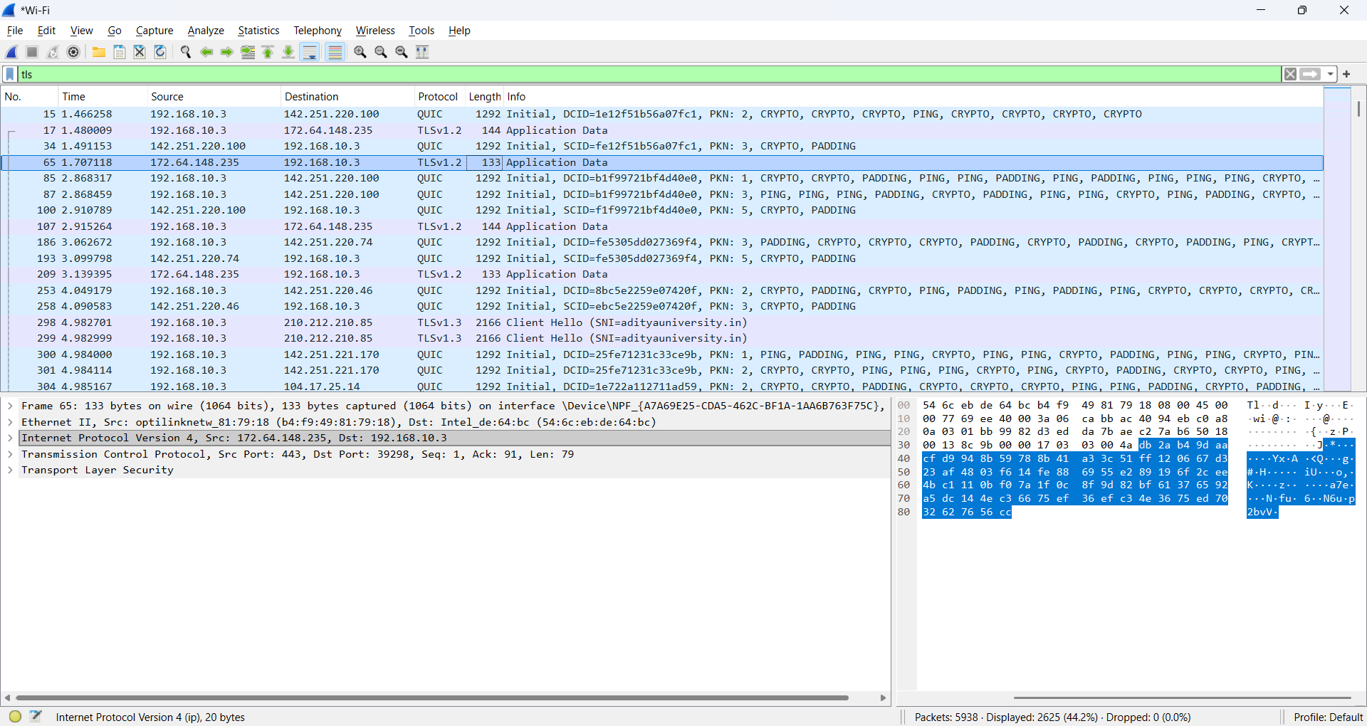
HTTPS traffic- in gibberish and unclear format.

- Capture DNS queries and analyze them:
DNS query:
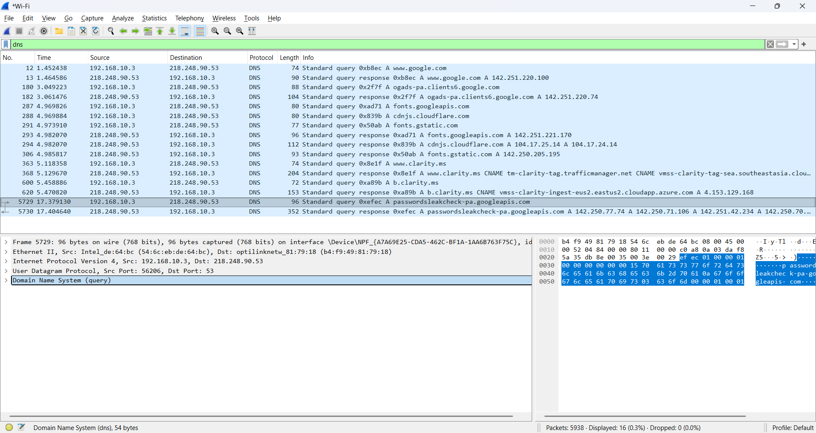

DNS response:
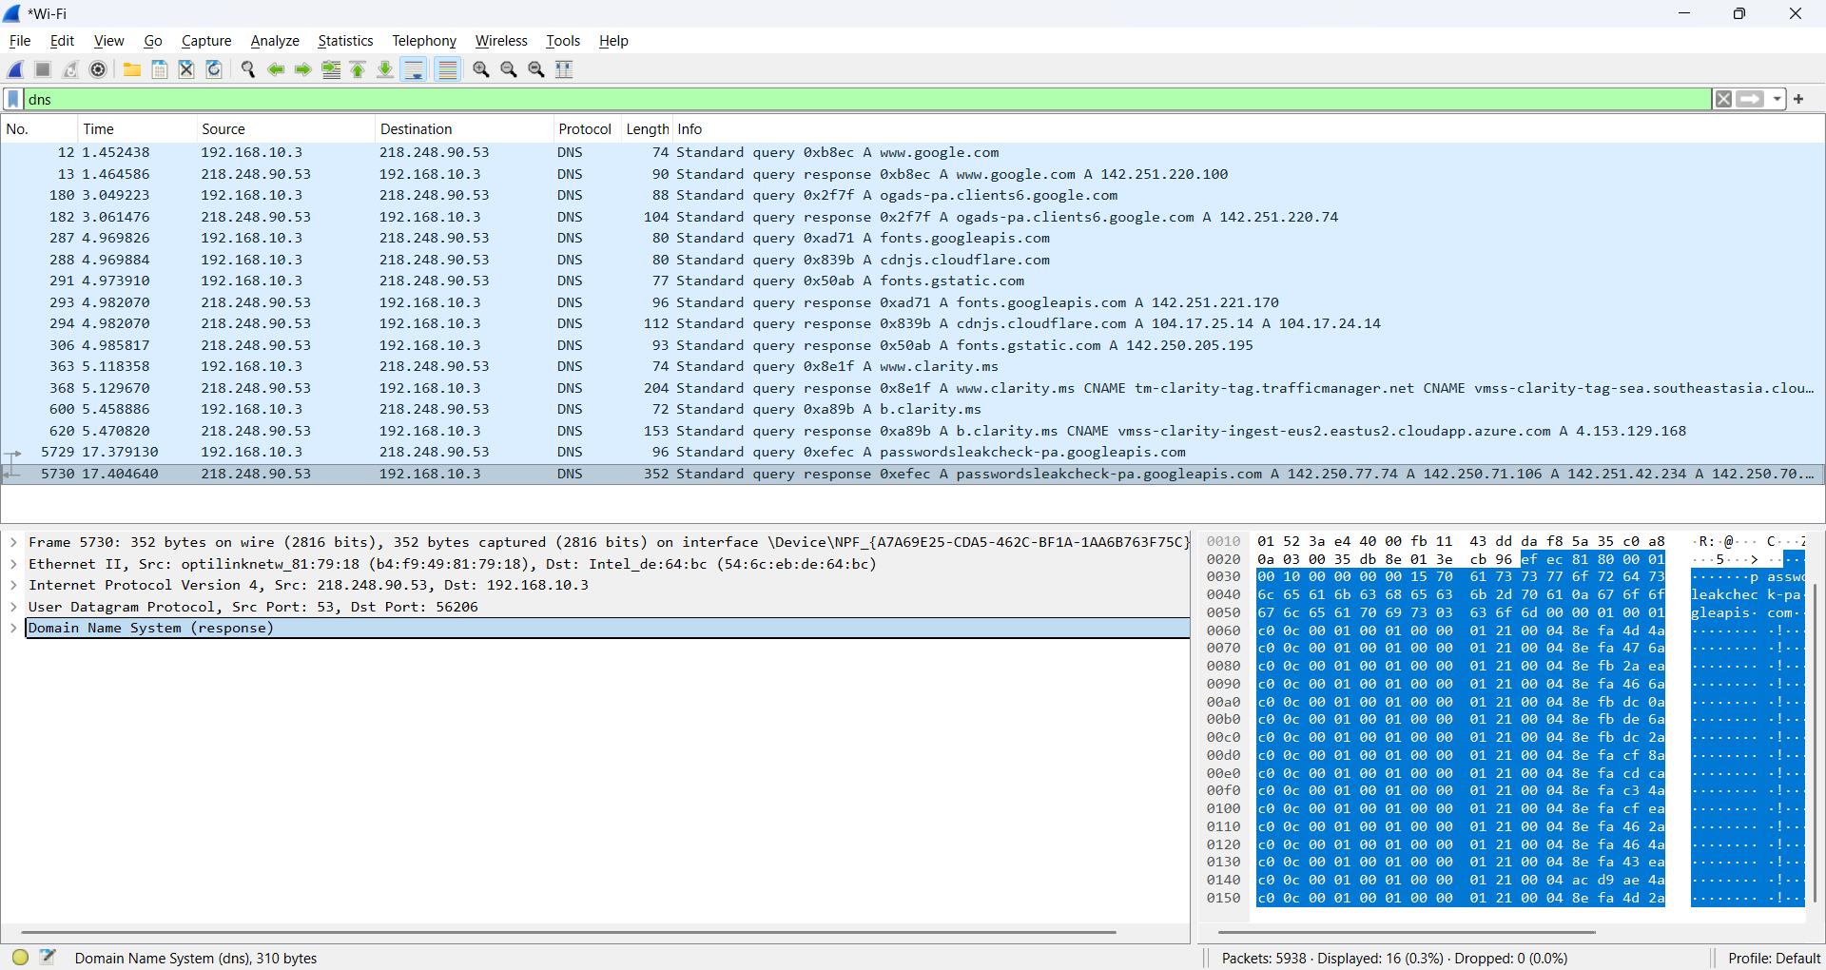
The captured packets clearly demonstrate the complete DNS resolution process that occurs when a user accesses a website. In the screenshots, the system with the private IP address 192.168.10.3 is seen sending multiple DNS queries to the DNS server 218.248.90.53 using UDP port 53, which is the standard port for DNS communication. These queries request A records, meaning the system is asking for the IPv4 addresses of various domain names required to load web content.
From the capture, it is evident that when a primary website such as www.google.com is accessed, multiple related domains are also queried automatically. These include domains like ogads-pa.clients6.google.com, fonts.googleapis.com, fonts.gstatic.com, cdnjs.cloudflare.com, and clarity.ms. This shows that modern websites do not rely on a single domain but instead load resources such as advertisements, fonts, analytics, and scripts from multiple external servers. Each of these DNS queries receives a corresponding DNS response from the server, containing one or more IP addresses, which confirms successful name resolution.
The second screenshot highlights a specific DNS query and response for passwordsleakcheck-pa.googleapis.com, which is a Google service used for password safety checks. The response packet contains multiple IP addresses, indicating the use of load balancing and distributed infrastructure, where traffic is spread across several servers to improve availability and performance. This behavior is common in large-scale cloud services and content delivery networks.
Overall, this combined capture confirms that DNS communication is unencrypted, allowing domain names to be visible in plain text during transit, even when the actual website traffic later uses HTTPS. From a cyber security perspective, this demonstrates how DNS traffic can reveal browsing behavior and why attackers often target DNS for monitoring, spoofing, or redirection attacks. The analysis successfully shows how DNS queries are generated, how responses are returned, and how multiple supporting domains are involved in loading a single website, reinforcing the importance of DNS monitoring in network security.

- Save packet captures for analysis:
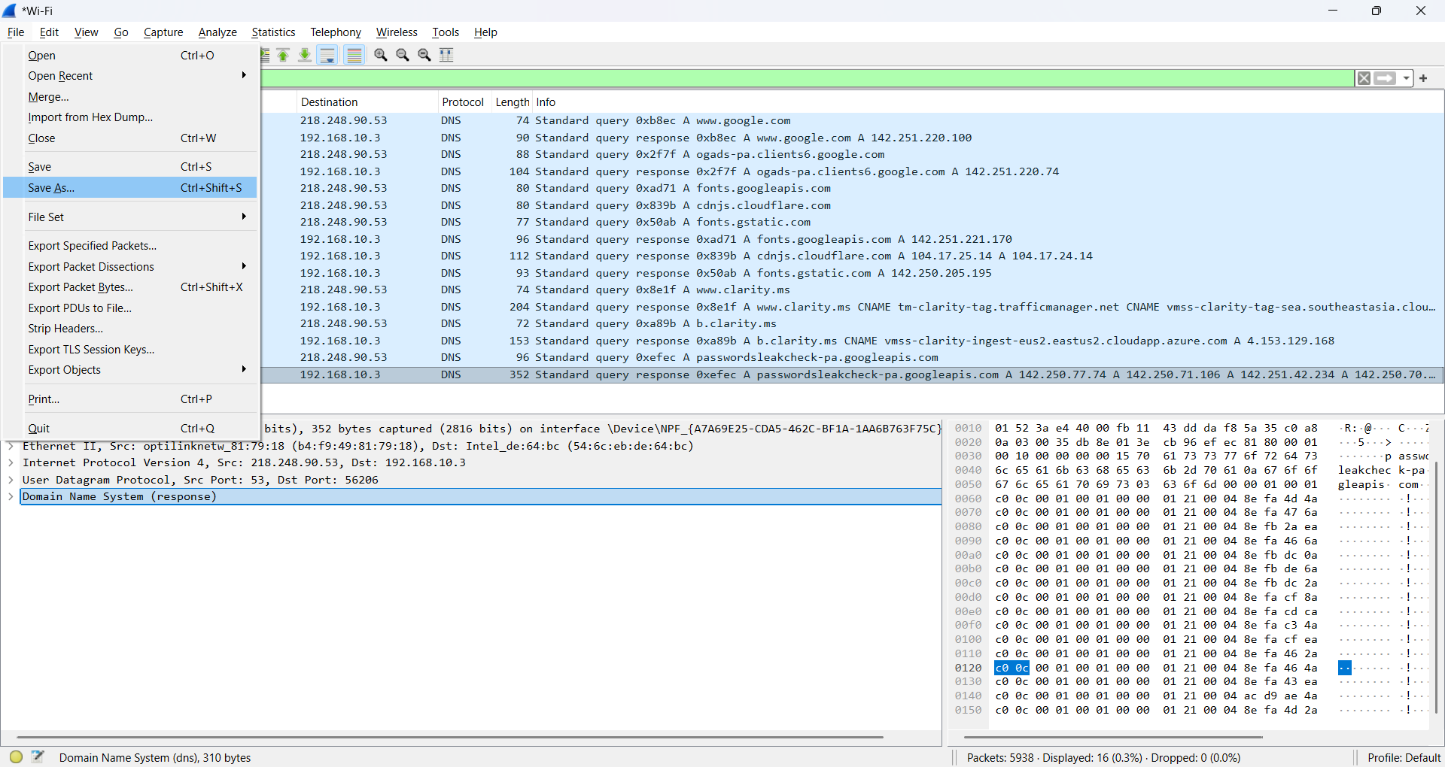
File → Save As → give the file name.

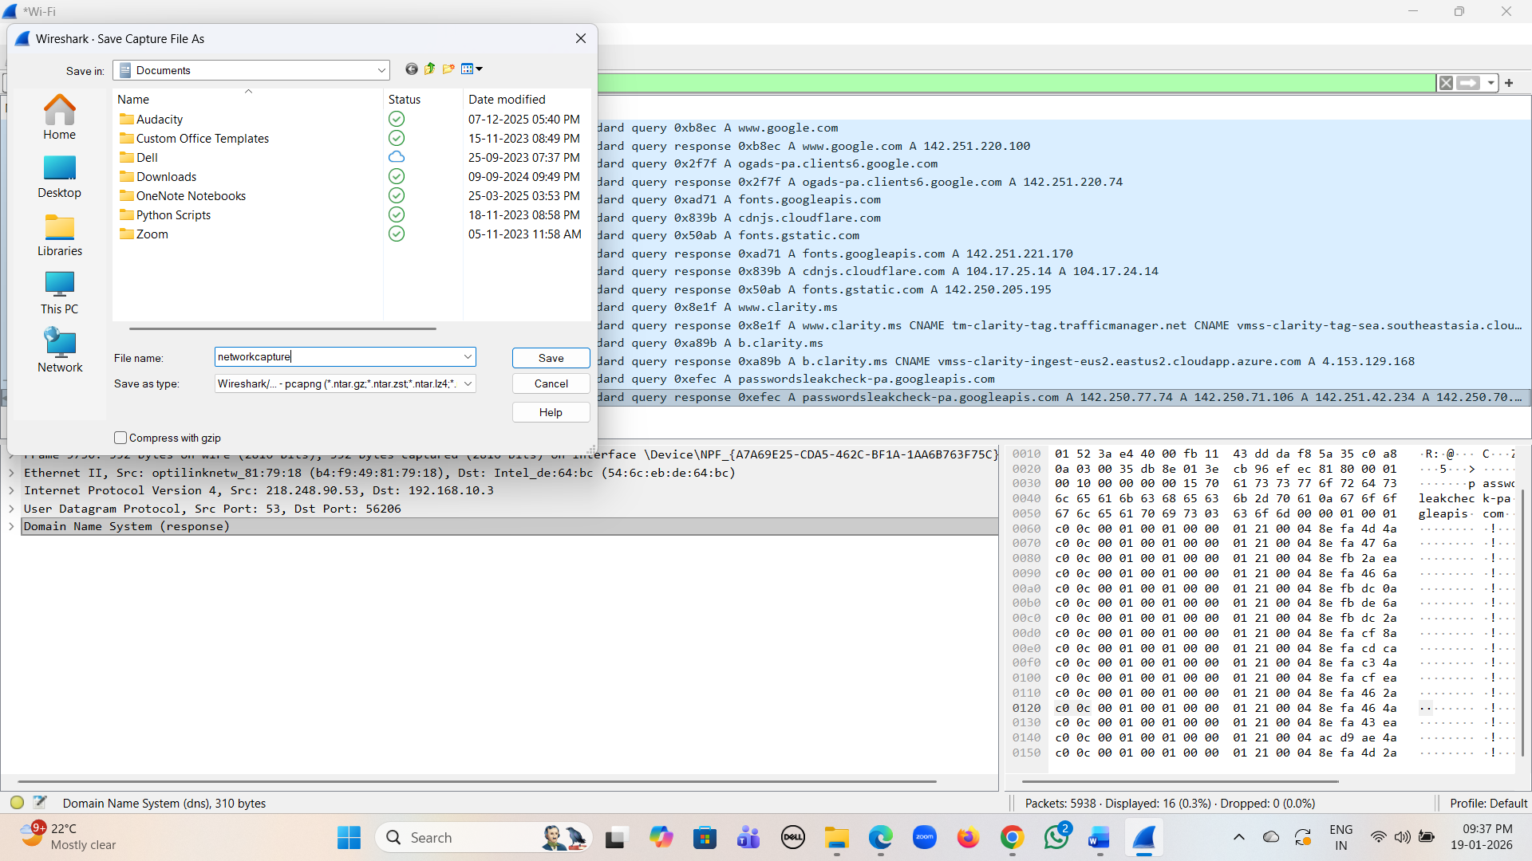
Observation:
While capturing live network traffic using Wireshark, it was observed that opening a website generates multiple network packets related to TCP, UDP, DNS, HTTP, and HTTPS protocols. The three-way TCP handshake was clearly seen through SYN, SYN-ACK, and ACK packets, confirming that TCP establishes a reliable connection before data transfer. HTTP traffic showed some information in plain text, whereas HTTPS traffic appeared encrypted, highlighting the importance of secure communication. DNS analysis revealed that domain names are sent in plain text to DNS servers using UDP port 53, and multiple DNS queries are generated for a single website due to external resources. These observations demonstrate how network traffic flows and why monitoring it is important for cyber security.

